Detailed Explanation of Data Types, Procedural vs Continuous Assignments in Verilog/SystemVerilog

1. Data Types in Verilog/SystemVerilog

1.1 Wire
- Definition: Represents a physical connection between hardware elements.
- Behavior: Requires a continuous driver (like assign) or connection to a module/gate output. Cannot store a value.
- Usage: Ideal for combinational connections and driving outputs.
- Example:
- wire a, b, c;
- assign c = a & b; // 'c' is continuously driven by the AND of 'a' and 'b'

1.2 Reg
- Definition: A data storage element that holds a value.
- Behavior: Used in procedural blocks (e.g., always, initial). Updates its value when explicitly assigned.
- Usage: Suitable for sequential logic.
- Example:
- reg d;
- always @(posedge clk) begin
- d = a & b; // 'd' updates on the clock edge
- end

1.3 Logic (SystemVerilog)
- Definition: A unified data type that can replace both reg and wire.
- Behavior: Can be assigned in both procedural (always) and continuous (assign) blocks.
- Usage: Recommended for most designs to avoid ambiguity.
- Example:
- logic a, b, c;
- assign c = a & b; // Continuous assignment
- always @(posedge clk) begin
- c <= a | b; // Procedural assignment
- end

Comparison of Wire, Reg, and Logic
Feature | Wire | Reg | Logic
Storage Capability | No | Yes | Yes
Continuous Assignment | Yes | No | Yes
Procedural Assignment | No | Yes | Yes
Recommended Usage | Interconnections | Sequential Logic | General-purpose

2. Procedural vs Continuous Assignments

2.1 Continuous Assignment
- Definition: Describes combinational logic where outputs are driven continuously based on inputs.
- Behavior: Used with assign statements.
- Example:
- wire y;
- assign y = a & b; // 'y' is continuously updated as 'a' and 'b' change
- Use Case: For combinational logic and module connections.

2.2 Procedural Assignment
- Definition: Used in procedural blocks like always or initial to describe sequential behavior.
- Behavior: Can use = (blocking) or <= (non-blocking).
- Example:
- reg q;
- always @(posedge clk) begin
- q <= d; // Non-blocking assignment for sequential logic
- end
- Use Case: For sequential logic and storage elements.

3. Blocking (=) vs Non-Blocking (<=) Assignments

3.1 Blocking Assignment (=)
- Execution: Executes immediately in the order written.
- Use Case: For combinational logic inside procedural blocks.
- Example:
- always @(*) begin
- y = a & b;
- z = y | c; // 'z' depends on the updated value of 'y'
- end

3.2 Non-Blocking Assignment (<=)
- Execution: Schedules the value to update at the end of the time step (delta cycle).
- Use Case: For sequential logic to model flip-flops and registers.
- Example:
- always @(posedge clk) begin
- q1 <= d; // 'q1' updates at the clock edge
- q2 <= q1; // 'q2' gets the old value of 'q1'
- end

Comparison of = vs <=
Feature | Blocking (=) | Non-Blocking (<=)
Execution Order | Immediate | Scheduled for later
Use Case | Combinational Logic | Sequential Logic
Timing | Happens in the current time step | Happens at the end of the delta cycle

4. Examples and Use Cases

4.1 Combinational Logic Example (Using wire)
module mux(output wire y, input wire a, b, sel);
assign y = sel ? a : b; // Continuous assignment for combinational behavior
endmodule

4.2 Sequential Logic Example (Using logic)
module d_flip_flop(output logic q, input logic d, clk);
always @(posedge clk) begin
q <= d; // Non-blocking assignment for sequential behavior
end
endmodule

4.3 Shift Register Example
module shift_register(output reg [3:0] q, input wire d, clk);
always @(posedge clk) begin
q[0] <= d; // Input to the first stage
q[1] <= q[0]; // Shift through the stages
q[2] <= q[1];
q[3] <= q[2];
end
endmodule

5. The initial block in Verilog and SystemVerilog is referred to as a procedural block because it defines a sequence of procedural statements that are executed sequentially during simulation.

A procedural block in Verilog/SystemVerilog contains statements that execute one after another, similar to a program's flow of execution in a procedural programming language (e.g., C).
- Procedural blocks control how and when the simulation executes specific tasks.
- Statements in procedural blocks operate on time (using # delays or clock events) and sequential flow.

Why is the initial Block Procedural?
- Sequential Execution:

Statements in the initial block execute in the order they are written.

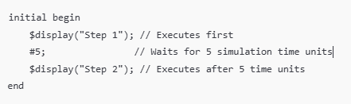
Example:

- Defined Start and End:
  - The initial block starts execution once at the beginning of simulation and terminates after all its statements are executed.
  - This is similar to a procedure that begins, performs a series of actions, and then ends.
- Control Over Simulation Events:
  - The initial block allows you to specify when certain tasks should occur, such as delays (#), waiting for signals (@), or executing loops.
- Supports Procedural Constructs:
  - Inside the initial block, you can use procedural constructs like loops (for, while), conditionals (if-else), and tasks/functions.
Difference Between initial and always Blocks

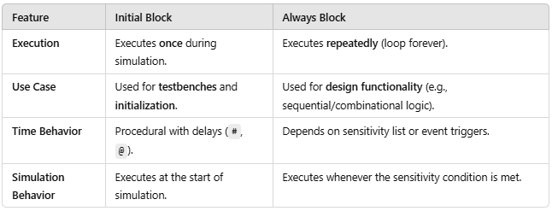

Why Use initial Blocks in Testbenches?
- Simulation Initialization:
  - initial blocks are commonly used to initialize signals or provide input stimulus for the design under test (DUT).
- Control Over Time:
  - initial blocks enable precise control over when events occur in the testbench (e.g., applying signals at specific time intervals).
- Event-Driven Behavior:
  - By combining delays (#), signal events (@), and loops, initial blocks can create complex procedural flows in a testbench.
- Delays:
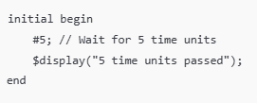

- Signal Events:
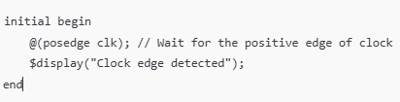
- Loops:
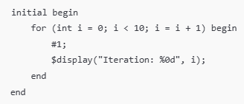
- Conditional Statements:
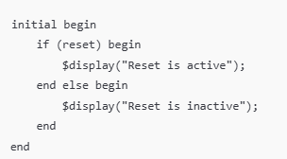
Note: In an initial block without any delays, all the statements are executed sequentially in zero simulation time. This does not mean they are executed "at the same time," but rather they occur one after another in the same simulation timestep (often referred to as delta time in event-driven simulators).
• Without delays (#), all assignments and operations occur in one simulation cycle.
• The order of execution matters because the results of earlier statements affect later ones.

Difference Between $stop and $finish
In Verilog/SystemVerilog, both $stop and $finish are system tasks used to control the simulation. However, they differ in functionality and use cases:
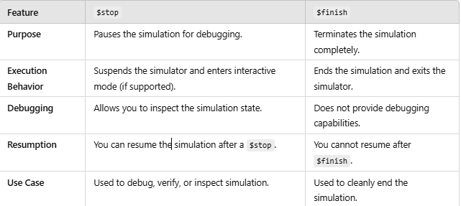

Int vs Integer

In SystemVerilog, int and integer are both data types used to represent integers, but they have some key differences in terms of bit width, sign, and use cases.

Comparison Between int and integer
Feature | int | integer
Bit Width | Fixed at 32 bits. | Typically 32 bits, but tool-dependent (can be 32 or 64 bits).
Sign | Always signed. | Always signed.
Standard | Introduced in SystemVerilog. | Exists in both Verilog and SystemVerilog.
Precision | Guaranteed to be 4 bytes (32 bits). | Precision may vary (depends on tool implementation).
Storage | Can be used in arrays and packed structures. | Cannot be used in packed arrays or structures.
Usage | Suitable for compact and efficient calculations. | Used for general-purpose arithmetic.
Behavior | More modern and versatile. | Legacy type, primarily for backward compatibility.

Details
1. int
- A SystemVerilog-specific data type.
- Always 32-bit signed, making it ideal for applications requiring portability and a consistent bit width.
- Can be used as part of packed arrays and structures, which allows for more compact storage and compatibility with other packed data types.

2. integer
- A legacy type from Verilog, still supported in SystemVerilog.
- Signed by default, but its size may vary based on the simulator (usually 32 bits, but could be 64 bits on some tools/platforms).
- Cannot be used in packed arrays or structures.
1. What is a string in SystemVerilog?
- The string data type in SystemVerilog is used to store and manipulate textual data.
- It is a dynamic array of characters, meaning the size of the string can change dynamically during runtime.
Key Features:
- Strings can grow or shrink dynamically as data is added or removed.
- Strings are null-terminated (\0) internally.
- SystemVerilog provides a rich set of methods to operate on strings, such as concatenation, comparison, and searching.
- Declaring and Initializing a String
string s1; // Declares a string variable
string s1 = "Hello, SystemVerilog!";
3. String Operations
3.1. Concatenation
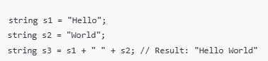
3.2. Comparison
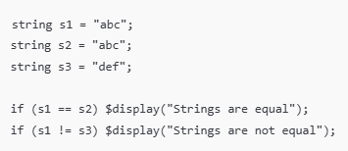
3.3. Assigning Substrings
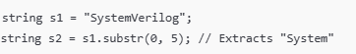

5. String Examples
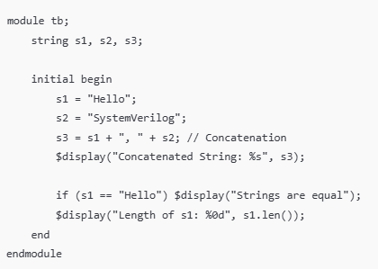
Output:
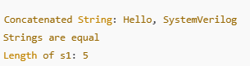
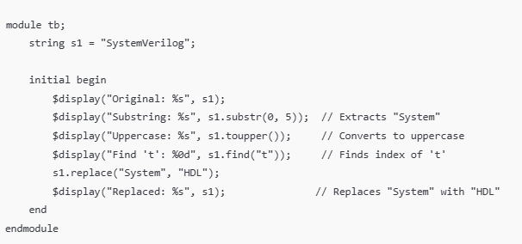
Output:
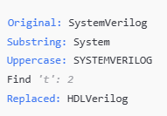
Dynamic String Resizing
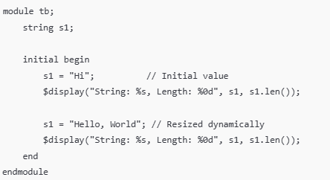
Output:
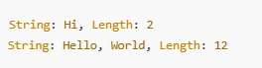
Integer to String Conversion

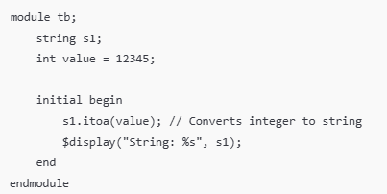
Output: String: 12345

